

**A Mini -Project Report**

**On**

**“TEXT TO SPEECH”**

**Python flask**

**Submitted by**

**P.PRAVEEN KUMAR (19B21A04B9)**

**R.MOUNIKA (19JN1A0439)**

**P.JAHNAVI SAI (19B21A0409)**

**D.JAYANTHI (19B21A0445)**

**N.PAVANI (19JN1A0501)**

**Departments**

**Electronics and Communication Engineering and Computer Science Engineering.**

**Submitted to**

**Dr.Krish Naik**

**Chief Innovation Officer**

**Submission Date: December 19,2021**

**INDEX**

ABSTRACT

LIST OF ABBREVATIONS

INTRODUCTION

AIM

TECHNOLOGIES USED

MODULES

SYSTEM REQUIREMENTS

CODE

THEORY

ADVANTAGES

CONCLUSION

**ABSTRACT**

This report represents the mini-project taken by our group of 5 students for the partial fulfilment of “TEXT TO SPEECH”, python -flask. It is a project of converting text into speech app. This is an NLP project

Keywords: Python -Flask , HTML, CSS, BOOTSTRAP, Java Script .

**LIST OF ABBREVATIONS**

**NLP - Natural Language Processing**

**HTML - Hyper Text Markup Language**

**CSS- Cascading Style Sheets**

**JS- Java Script**

**INTRODUCTION**

The main aim of the project is to convert text into speech directly by using HTML as index page and CSS for styling and JS for complete operation.

“FLASK” is a web frame work so any one can directly open the website and use this.

**AIM**

Our Aim is to convert text to speech by building an app. So people can interact with our application in live.

**TECHNOLOGIES USED**

Python

HTML

CSS

JS

BOOTSTRAP

FLASK

**MODULE(S)**

**Windows.speechsynthesis**

**This module is used to get voices.**

**SYSTEM REQUIREMENTS**

**Hardware Requirements:**

RAM: 4GB and higher

Processor: Intel I3 and above

Hard Disk: 500GB: Minimum

**Software Requirements**:

OS: Windows or Linux

Python IDE: Python 2.7 and above

VS CODE

PYCHARM

Setup Tools and pip to be installed for 3.6 and above

Language: Python

**CODE**

**HTML CODE**

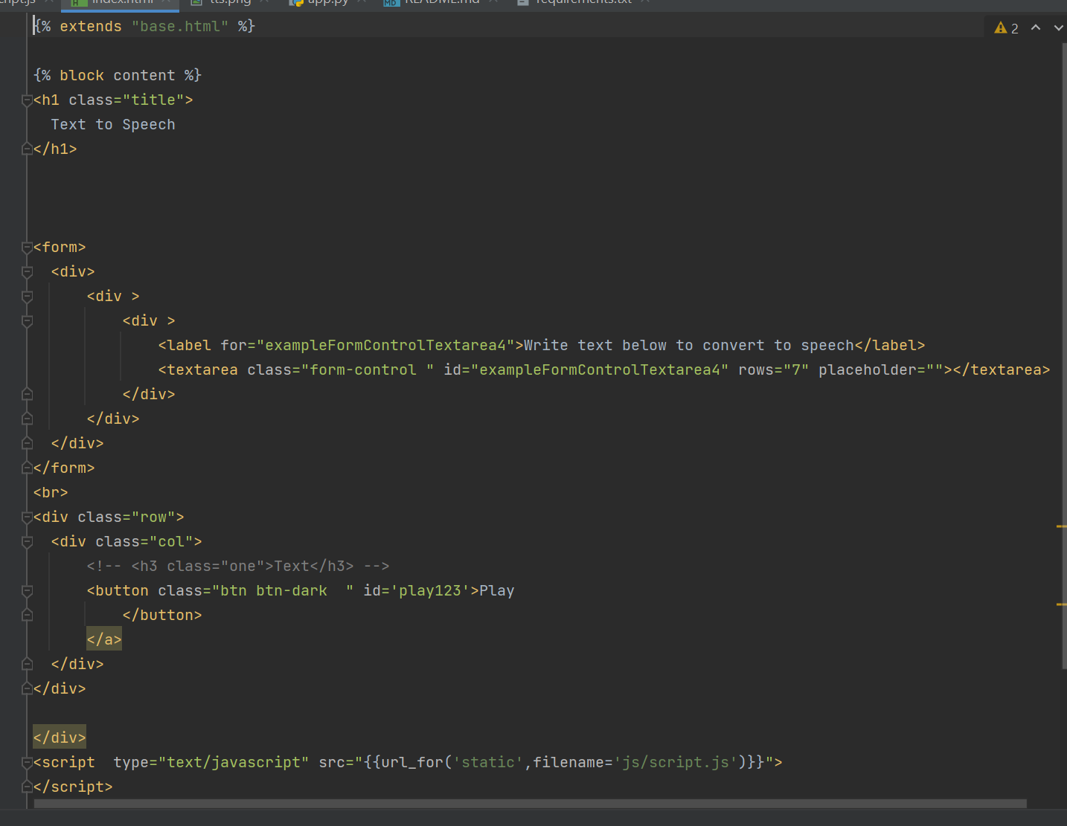

HTML & CSS CODE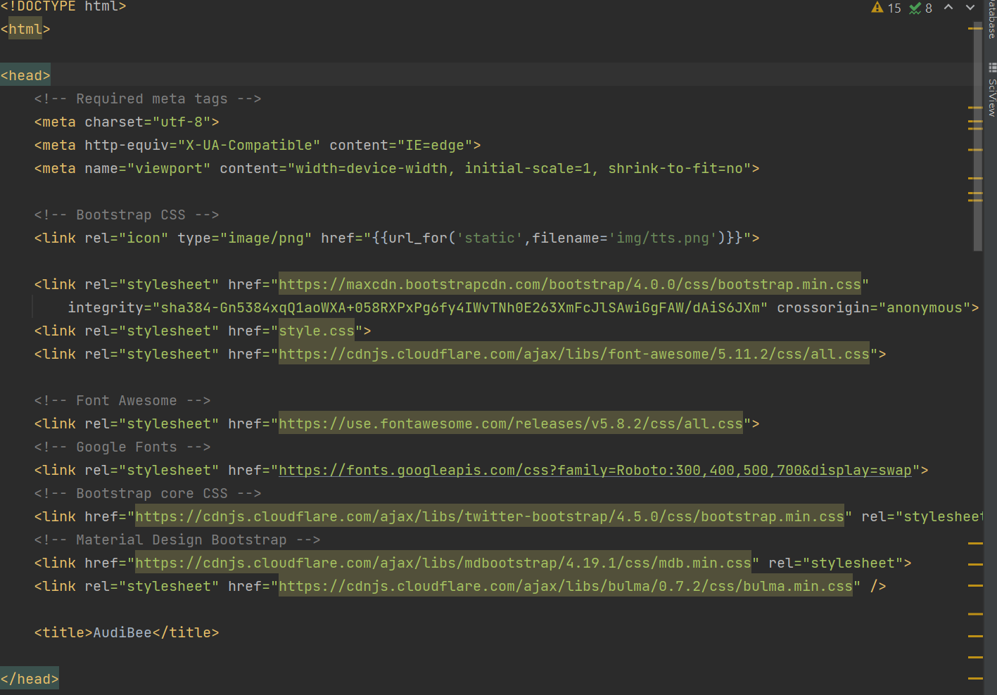

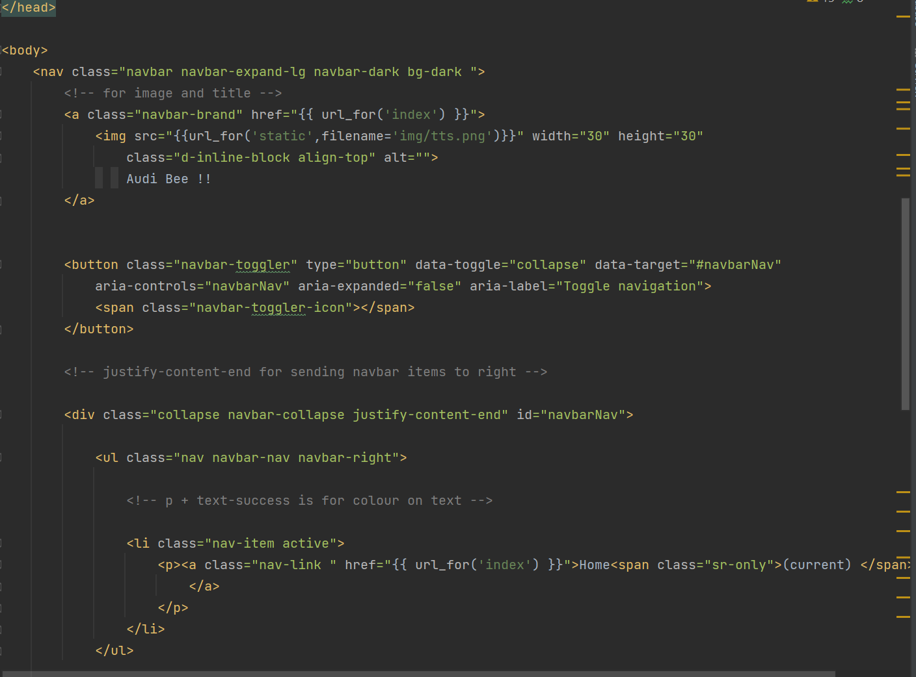

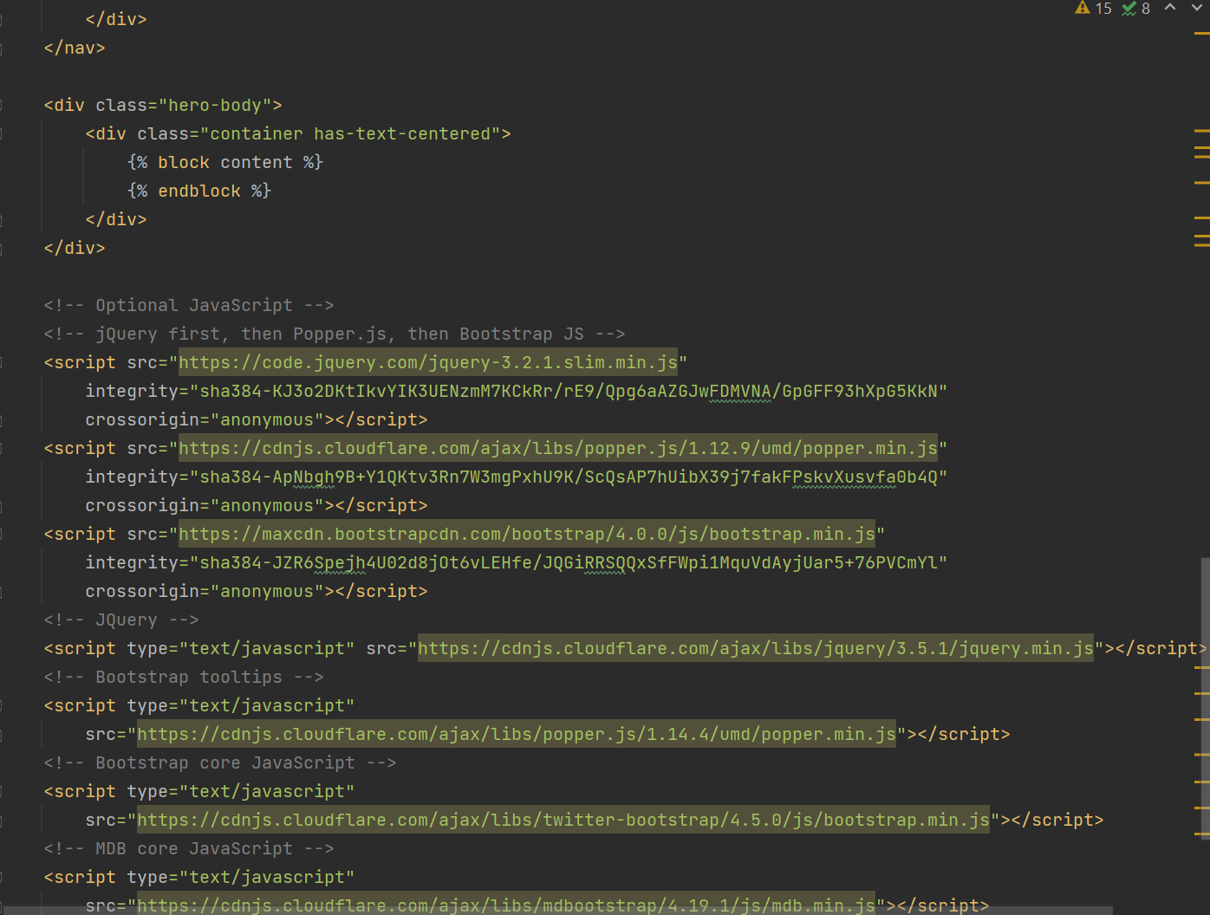

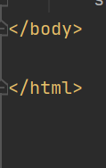

JAVA SCRIPT

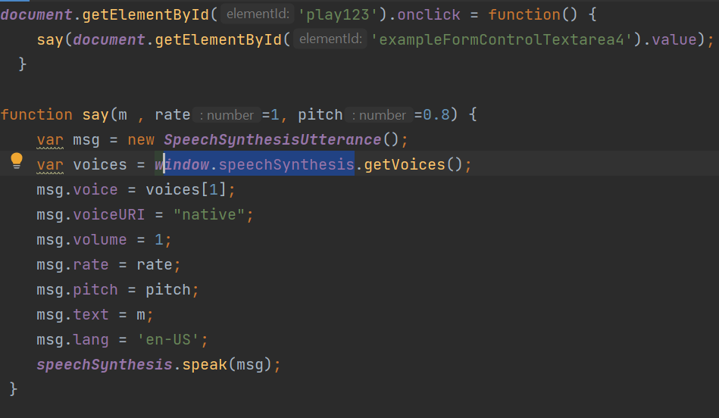

PYTHON FLASK

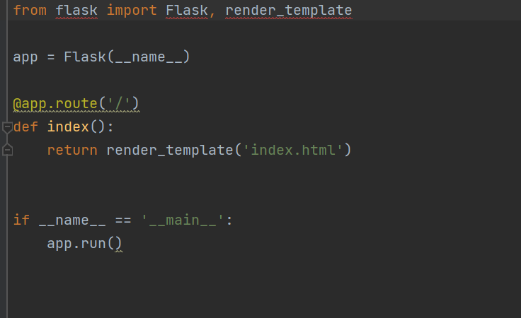

**THEORY**

The text that is written by user in our application will be directly converted to speech by following code works at back end.

HTML is our main page which contains a form that takes inputs from the user in the form of TEXTS then the text will be saved in play123 temporarily.

Java script code fetches play123 file and by using **Windows.speechsynthesis (**This module is used to get voices by using function getvoices( ) )

This function contains speech rate and pitch of voice generated and it will be us.

**ADVANTAGES**

1)People who don’t have time to read novels stories and even daily news papers then can listen directly from our app.

2)This can give voice to dumb people.

**SOLUTION**

This model will be biggest and economically useful solution for dumb people.

**CONCLUSION**

We hereby conclude that this app is completely user friendly and done with flask.